Personal Finance Tracker
Schema
1st (transactions)
Id | name | type | amount | date

First commit Handle view error · nemoirisgurl/finance@0abb1cf
- Created table “transactions” which had Id as a primary key and other attributes.
Id | name | type | amount | date
CREATE TABLE IF NOT EXISTS transactions(
id INTEGER PRIMARY KEY,
transaction_name TEXT,
transaction_type TEXT CHECK (transaction_type IN ('income', 'expense')),
amount REAL,
transaction_date TEXT DEFAULT CURRENT_DATE
);
-Added basic view/add rows to transactions table with python and sqlite3 library.

Second commit Add feature to show specific type and handle some errors · nemoirisgurl/finance@04021fa
-Added choices to show only income or expense.
-Handled basic errors like no columns or uninitialized database.

Third commit Calculate balance from date · nemoirisgurl/finance@037cabd
-Showed sum of incomes and sum of expenses and balance from start_date to end_date.
-Used regular expression to check date input if it matched a format (YYYY-MM-DD).

Fourth commit Milestone-2 · nemoirisgurl/finance@7358eb6
-Could time-travel to add transactions.
-Added a function to delete a transaction or a table.
-Visualized transactions table with tabulate library.
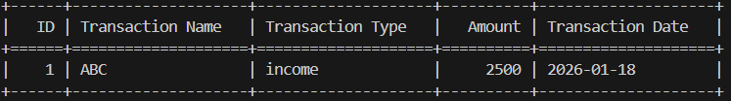
-Added README and requirements files.

Fifth commit Tidy up with directories · nemoirisgurl/finance@2754853
-Added a function to check if input date is valid or not.
If valid add or view or even calc
If not back to menu and error shows
-Restructured main code to smaller modules.
database.py contains database features
helpers.py helper functions
main.py main application

